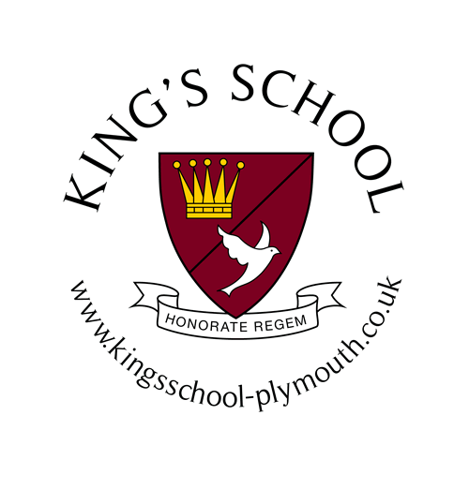
King’s School Uniform
 | Girls | Boys
Foundation | School Coat  Maroon School Jumper  Sports Kit – (maroon shorts, top and PE Bag), Maroon tracksuit (top and bottom)  School Book Bag  Black School Shoes  Maroon Legionnaires Hat  Pink Ballet shoes and pink leotard with skirt  Summer Pink candy stripe dress with white ankle socks  Winter Lindsay Tartan pinafore, open neck revere blouse with maroon socks or tights | School Coat  Maroon School Jumper  Sports Kit – (maroon shorts, top and PE Bag) Maroon tracksuit (top and bottom)  School Book Bag  Black School Shoes  Maroon Legionnaires Hat  White Crested Polo Shirt  Black Ballet Shoes  Summer Mid grey Bermuda shorts  Winter Grey shorts or long mid-grey trousers
Reception, Year 1 and 2  (Infant Department) | School Coat  School Blazer  School Maroon Jumper  School Sports Kit – (maroon shorts, top and PE Bag)  Maroon School Track Suit  Black Plimsolls  School Book Bag  Black Shoes  Legionnaire’s hat  Pink Ballet shoes and pink leotard with skirt  Summer Pink candy stripe Dress with white ankle socks.  Winter Lindsay Tartan pinafore, open neck revere blouse, maroon socks or maroon tights. | School Coat  School Blazer  School Maroon Jumper  School Sports Kit – (maroon shorts, top and PE Bag)  Maroon School Track Suit  Black Plimsolls  School Book Bag  Black Shoes  Legionnaires Hat  Black Ballet Shoes  Summer White short sleeved shirt with mid grey Bermuda shorts  Winter White Shirt and school tie with grey shorts or long grey trousers
Year 3, 4, 5 and 6  (Junior Department) | School Coat  School Blazer  School Jumper with logo  PE Kit – School hooded top with black bottoms, maroon polo shirt, black skort, maroon sports socks, school Maroon PE bag and trainers, Black or White.  School book bag  School rucksack  Black school shoes  School cap  Summer – Maroon and white striped dress with white ankle socks  Winter – Lindsay Tartan kilt, open neck revere blouse with and maroon socks or tights. | School Coat  School Blazer  School Jumper with logo  PE Kit – School hooded top with black bottoms with maroon polo shirt and maroon shorts, maroon sports socks, maroon PE bag and trainers  School book bag  School rucksack  Black school shoes  School cap  Summer – White short sleeved shirt, with mid grey Bermuda shorts  Winter –White Shirt and school tie with grey shorts or long grey trousers,

Item | Size Age | Cost | Qty | Total
Coat with school crest | 3/4, 5/6, 7/8, 9/10, 11/12, 13 | £32.50
Blazer with school crest | 22”, 24”, 26”, 28”, 30”, 32”, 34” | £35.00
Maroon Jumper with school crest | 24”, 26”, 28”, 30”, 32” | £19.00
 | 34”, 36” | £20.00
School book bag with logo |  | £8.50
School Rucksack (Juniors) |  | £19.50
School Tie | Infant or Junior | £5.50/  £6.00
White Polo shirt with school crest - Foundation only | 22", 24", 26", 28" | £9.50
Pink Candy Stripe Dress (Summer, Foundation and Infants) | 18”, 20”, 22”, 24”, 26”, 28”, 30”, 32”, | £31.50
Maroon and White Striped Dress (Summer, Juniors) | 24”, 26”, 28”, 30”, 32”, | £32.00
 | 34”, 36”, 38” | £33.50
Lindsay Tartan Pinafore (Winter, Infants) | 22”, 24”, 26” | £32.00
 | 28”, 30”,32” | £36.00
Tartan Kilts (Winter, Juniors) (Waist/Length) | 22/18, 22/20 22/22 | £35.00
 | 24/20, 24/22, 24/24 24/26 | £35.00
 | 26/22, 26/24 26/26 | £36.50
 | 28/22, 28/24 28/26 28/28 30/24 30/26 | £38.50
Hair accessories - velvet scrunchy │cotton scrunchy│velvet hairband│cotton hairband│clipit hair slides│bobbles selection pack | Please circle your choice(s) | All £2.00 each
Sports Kit includes maroon top, shorts (Foundation and Infants) | 3-4, 5-6, 7-8 | £11.50
Maroon Tracksuit Top with Crest (Infants) | 24” 26” 28” 30” 32” | £14.50
Maroon Tracksuit bottoms (Infants) | 3-4, 5-6, 7-8 | £14.00
Maroon Hooded Top with Crest (Juniors) | 7/8, 9/10, 11/12, 13 | £19.00
Black Tracksuit bottoms (Juniors) | 7/8, 9/10, 11/12, 13 | £15.00
Maroon Polo Shirt with School Crest (Juniors) | 26”, 28”, 30”, 32”, 34” | £9.50
Black Skort (Juniors) | 22”, 24”, 26”, 28”, 30”, 32”, | £12.50
PE Bag (Juniors) | One size | £7.50
Girls Maroon Socks (Winter)  3 pairs per pack | 6-8,½ / 9-12 /12½-3½ / 4-7 | £6.50
Maroon Tights (Winter) | 2-3 3-4 | £6.00
 | 5-6 7-8 | £6.00
 | 9-10 11-12 | £6.00
 | Teen | £6.50
Maroon sports socks (junior boys and girls) | 9-12 / 12-2 / 3-6 | £5.00
Maroon gloves (unisex) | Small or large | £5.00
Legionnaires Hat with School Crest |  | £6.00
Juniors Summer cap | One size | £6.00
Maroon fleece hat with logo (unisex) | Small or large | £8.50
Maroon stretch Junior’s wool hat |  | £6.00
Combined Total
Name of Child: Year Group:
Boys and Girls shirts can be bought from high street retailers along with trousers and shorts.
Payments must be made through Cognita Connect. The details will be added after the order is received.

